**Dr. Babasaheb Ambedkar Technological University**

University Campus, Lonere, Maharashtra, 402103



A MINI PROJECT REPORT ON

**“SOLAR BASED EVAPORATING TECHNOLOGY**

**FOR VEGETABLE STORAGE IN INDIA”**

Submitted by

DHIRAJ NARENDRA MAHAJAN (EE – 249)

RUSHIKESH KISAN KAKADE (EE -207)

KAUSTUBH KAKASAHEB DUBE (EE -238)

POOJA DEVIDAS MANE (EE -250)

Under the Guidance of

**Prof. M. G. AUSH**

Electrical Engineering Department

For the partial fulfillment for the award of

BACHELOR OF ELECTRICAL ENGINEERING



CSMSS

**CHH.SHAHU COLLEGE OF ENGINEERING**

Kanchanwadi, Aurangabad – 431005

**Electrical Engineering Department**

**(2021-22)**

**CSMSS**

**CHHATRAPATI SHAHU MAHARAJ SHIKSHAN SANSTHA’s**

**CHH. SHAHU COLLEGE OF ENGINEERING**

Approved by AICTE New Delhi, DTE (Govt. of Maharashtra) and affiliated to Dr. B.A.M. University, Aurangabad.

Kanchanwadi, Paithan Road, Aurangabad 431 002 (M.S)

Ph. No.: (0240) 2379248, 6646463 Fax: (0240) 2379015

Email:[shahuengg@gmail.com](mailto:shahuengg@gmail.com), [principal@csmssengg.org](mailto:principal@csmssengg.org) Website : [www.csmssengg.org](http://www.csmssengg.org)

**CERTIFICATE**

It is a bonafide work carried out by Dhiraj Narendra Mahajan (EE-449), Rushikesh Kisan Kakade (EE-407), Kaustubh Kakasaheb Dube (EE -438), Pooja Devidas Mane (EE-450) in partial fulfillment for the award of degree of Bachelor of Technology in Electrical Engineering of the Dr. Babasaheb Ambedkar Technological University, Lonere Dist. Raigad during the academic year 2021-2022. It has been certified that all the corrections and suggestions has been incorporated in the report. The project report has been approved as it satisfies the academic.

**Guide HOD Principal**

**Prof. M. G. Aush Prof. A. N. Mudiraj Dr. U.B. Shinde**

**Examiner:**

1. **Prof. A. D. Salpe Sir -**
2. **Prof. N. B. Surwase Sir-**

**ACKNOWLEDGEMENT**

It gives us a great pleasure to submit this seminar report. This is the only page where we have the opportunity to express my emotions and gratitude from the bottom of my heart.

We express our sincere thanks to our guide **Prof. M. G. Aush** sirfor guiding us at every step in making of this project. He/she motivated us and boosted our confidence and we must admit that the work would not have been accomplished without his guidance and encouragement.

We are also thankful to project coordinator **Prof. M. G. Aush** sirfor guiding and encouraging us as per requirement.

We would like to extend our special thanks to HOD **Prof. A. N. Mudiraj** sir and principal **Dr. U. B. Shinde s**ir for spending their valuable time to go through our report and providing many helpful suggestions lastly, we would like to thank all the staff member of Electrical Engineering Department and our friends without whom the project report would not have been completed.

**INDEX**

|  |  |  |
| --- | --- | --- |
| **Sr. No.** | **Topic** | **Page no.** |
| **1** | ABSTRACT | **5** |
| **2** | INTRODUCTION | **6** |
| **3** | PROJECT OVERVIEW | **7** |
| **4** | NEED OF EVAPORATING COOLING | **8** |
| **5** | BACKGROUND OF INVENTION | **9** |
| **6** | WHAT IS EVAPORATING COOLING? | **10** |
| **7** | BENEFITS OF EVAPORATING COOLING | **11** |
| **8** | STORAGE CONDITIONS AND FACTORS AFFECTINGFRESH FRUITS AND VEHETABLES | **12** |
| **9** | CONSTRUCTION | **13** |
| **10** | DESIGN METHODOLOGY | **13** |
| **11** | Design of Model | **17** |
| **12** | Hardware Requirements | **19** |
| **13** | Conclusion: | **20** |
| **14** | References | **21** |

**ABSTRACT**

Practical and affordable storage technologies have the potential to prevent food loss, strengthen the perishable food supply chain, and create opportunities for additional income generation. Evaporative cooling devices are simple and inexpensive ways to keep vegetables fresh without the use of electricity. These devices function according to a basic principle called “evaporative cooling,” where the evaporation of water from a surface removes heat, creating a cooling effect.

Evaporative cooling can improve vegetable storage shelf life by providing a stable storage environment with low temperature and high humidity, which reduces the rate of respiration and water loss and spoilage in most vegetables. The improved storage environment can have positive impacts including reduced post-harvest losses, less time spent traveling to the market, monetary savings, and improved nutrition.

The system is an economical and efficient method used for the reduction of temperature and increase in the relative humidity for the storage of produce by applying the principles of the evaporative of water.

The pH and the total solubility solids of the fruits & vegetables stored with the evaporative cooler were the lowest showing that while the refrigerator was the best in terms of maintaining the skin firmness, the evaporative cooler was the best storage method in terms of preserving the acidity of the fruits & vegetables as well as their total solubility solids.

The most effective method utilized in storing produce involves refrigerated cool stores.

However, many small-scale farmers and vendors in the Caribbean region and in most developing countries are unable to incorporate such methods in preserving fruits due to its high cost with respect to installation, energy consumption and maintenance. Currently, the business revenue of many farmers in the region is limited due to the high loss in produce.

A device can be designed and constructed in order to maximize the shelf life of the produce, thus reducing the losses endured by small scale vendors & farmers.

Evaporative coolers can be easily constructed using available local materials. They are environmentally friendly without pollution.

**Keywords:** Evaporative, Agriculture, Refrigerator, Cooler, Saturation, Temperature Controlled, Effectiveness, pH, humidity, eco-friendly.

**Introduction:**

In today’s society many individuals strive to maintain a healthy lifestyle consisting of a balanced diet of fresh fruits and vegetables. As the demand for such produce increases, so too does the rate of post-harvest loss, as a result of inadequate facilities to store such produce. It was estimated that the average post-harvest loss in fresh produce in most developed countries is 5% to 25% and 20% to 50% in the developing countries.

Food, water, and electricity are what many people consider basic needs, but these are still luxuries to many people around the world. Imagine spending up to an hour walking to purchase vegetables every day because you don’t have a way to store vegetables that keeps them fresh and pest-free. This is exactly what happens to many people in communities where access to electricity or affordable vegetable preservation methods are limited. Regionally, harvesting is done early in the morning in order to maximize the lower temperatures because under temperatures of 25°C to 35°C that typically exists in the afternoons, the respiration rate is high thus reducing the storage life.

Undesirable effects of excessive temperature on produce include accelerated ripening, yellowing, spouting and bitter taste which are directly linked to respiration, transpiration and ethylene production. This is due to the higher respiration rates.There is therefore the need to decrease the temperature of the produce thereby decreasing its respiration rates, water loss, ethylene production and sensitivity to it as well as reduce microbial development.

Low relative humidity increases the transpiration rates, while at high relative humidity, the rate of water evaporation is low hence cooling is low. At high relative humidity, produce will generally maintain its nutritional quality, appearance and flavor with minimal effect on the softening and wilting. In order to create such a device, the requirements and parameters affecting the storage life of these produce must be analyzed. A major contributing factor to the cooling process incorporates the natural resource, water in conjunction. Evaporative coolers can be easily constructed using available local materials.

The design of such a device aims at finding an appropriate balance at increasing the storage life of produce based on the use of a low-cost evaporative cooler made with local materials. The optimal conditions for running the cooler will be investigated and compared with the current methods of storing produce. The cold storage stabilizes the price of the product, provides equal distribution and marketing of the product. It is being realized that proper and timely storage of product is an essential factor in the agriculture industry and due importance is given for the same. Storing farmed products enhances their shelf life and also facilitates continuous supply of products in the market.

Research has suggested that the Indian cold storage industry is making a steady growth and the annual growth rate is estimated to be 25.8%. Currently there are 6227 cold stores in India and they capable of storing a produce pf 30 million tones. Cold storages are generally used for storing agricultural produce, processed food, animal husbandry produce, pharmaceutical products etc.

**Project Overview:**

Food, water, and electricity are what many people consider basic needs, but these are still luxuries to many people around the world. Imagine spending up to an hour walking to purchase vegetables every day because you don’t have a way to store vegetables that keeps them fresh and pest-free. This is exactly what happens to many people in communities where access to electricity or affordable vegetable preservation methods are limited. In Sub-Saharan Africa alone, 30% to 50% of fruits and vegetables harvested are lost before reaching the consumer.

One way this problem can be addressed is through the promotion and use of clay pot coolers for storing and preserving fruits and vegetables. They are an affordable and accessible solution that use evaporation for cooling and do not require electricity to run. The most common clay pot coolers, or “Zeer pots,” are made of a double-wall earthenware. When the water from the outer surface evaporates, the inside of the container where the vegetables are stored - is cooled.

While clay pot coolers and other evaporative cooling technologies have been shown to effectively increase the shelf life of many fruits and vegetables, these technologies have not gained widespread adoption. This is because of the lack of product evaluations based on real-world scenarios and user behaviour to inform the design of dissemination programs.

1. ***Need of Evaporative Cooling:***

Although clay pot coolers and other evaporative cooling technologies have the potential to address challenges related to post-harvest food loss in rural communities, it is important to determine the appropriateness of these solutions by having the target users test the product Evaluating Suitability and User Needs in their environment.

Storing vegetables with a short shelf life with an arid climate and scarce access to electricity, is challenging. However, the study revealed that clay pot coolers increased the shelf life of vegetables by providing a stable storage environment with low temperature and high humidity. The most commonly stored vegetables were eggplant, tomato, hot pepper, cucumber, cabbage, and sweet potato leaves, and 97% of participants reported improved shelf life for one or more of these vegetables when they were stored in a clay pot cooler. During the dry season, the average temperature in the interior of the clay pot coolers was 5 °C to 7 °C lower than the ambient temperature and maintained a relative humidity above 80%. During the dry season, the average temperature in the interior of the clay pot coolers was 5 °C to 7 °C lower than the ambient temperature and maintained a relative humidity above 80%. The cooling effect is most pronounced during the middle of the day, with reduction between 7 °C to 10 °C, when the temperature is the highest, the relative humidity is the lowest, and vegetables are most susceptible to spoilage. Furthermore, the participants revealed benefits that came with using the clay pot cooler such as financial savings due to reduced food loss, less time and money spent traveling to the market, increased availability of nutritious vegetables for their families, improved hygiene of the vegetables, and protection from animals and insects. The combination of results from the performance study and user feedback indicated that both the clay pot is a suitable and effective solution for many households, farmers and vegetable vendors.

1. **Background of Invention:**

India produces large quantities of fruits (11.36%) and vegetables (14.04%) on the global scale, but there is less motivation for storing the product. Therefore, the loss due to insufficient post-harvest management (cold storage) is estimated around 133 billion rupees per year. The present requirement for cold storage facility is around 61 million tones in India for both vegetables and fruits, but the availability of storage now in India is just around 26.85 million tones. The non-availability of storage space has resulted in loss has resulted in loss of productivity, which is increasing gradually. Initially the loss was 25%, but now it has reached 40% of the total production. This loss creates a big difference between the quantities produced and consumed.

Farmer grows crops after a lot of hard work and need to store before giving it to venders or customers, but due non-availability of cold storages and their high cost it becomes difficult for them. The leafy green vegetables will starts deteriorating after one day due to atmospheric temperature and humidity. The vendors trying to keep them fresh by sprinkling water on the vegetables directly that is the main reason for the declining life of the vegetables. The water spread directly on them deteriorates vegetables and fruits and it can’t keep it fresh more than 24 hours. The refrigeration system available in the market is very costly, the small-scale farmers and vendors can’t afford that.

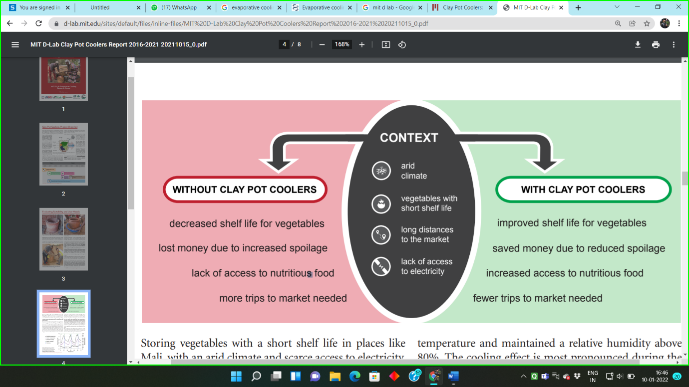

We are proposing the solution of evaporative cooling for improving vegetable storage in India.

1. **What is Evaporative Cooling?**

Evaporative cooling, otherwise known as adiabatic cooling, works on the principle of water evaporation through which the air is cooled down to a comfortable temperature.

It is a cooling and ventilation technique that uses water as its refrigerant. During the evaporative cooling process, water is evaporated in a stream of air and passes from a liquid to a gas. This transition requires energy, which is extracted from the air in the form of heat. As a result of this process, the air is cooled down.

Evaporative cooling, by means of an indirect/direct system, is a highly sustainable and energy-efficient cooling method that provides a comfortable and productive climate for production facilities, distribution centres, and office buildings. The evaporative cooling process in an indirect/direct cooling system uses 10% of the energy that is needed for mechanical cooling while delivering more or less equal temperatures as traditional mechanical cooling systems. Furthermore, unlike mechanical cooling, evaporative cooling does not recirculate the warm, polluted indoor air, but ventilates 100% fresh, filtered, clean, and cooled air into a room or building. As a result, the indoor air quality substantially improves.

1. ***Benefits for Evaporative* Cooling:**

The benefits of evaporative cooling are many, especially, provides the most sustainable and environmentally friendly cooling. Evaporative cooling uses 100% fresh, filtered outside air to cool down the vegetables and fruits. Evaporative technology ensures a relative humidity level between 40 and 70%. This humidity level promotes the protection against viruses and provides the necessary comfort for the throat, nose, and eyes.

Evaporative cooling is highly efficient in its energy usage. The system uses only 10% of the energy that is used by mechanical cooling to cool a room or building effectively. 95% of the cooling capacity is provided through the natural process of water evaporation. The low resistance of the components in combination with very economical direct current fans ensure high efficiency and low energy consumption. The motor-driven fan that regulates the adiabatic process requires 1 kWh of electricity and provides up to 40 kWh of cooling power. In comparison, mechanical cooling systems produce only 3 kWh cooling power with 1 kWh of electricity.

On hot days the cooling efficiency of the two-stage evaporative cooling system increases*.*Warmer temperatures allow for more moisture in the air, and thus the system can evaporate more water. And the more water is evaporated, the more cooling power the system can provide, without increasing its energy consumption.

Evaporative cooling is the most environmentally friendly cooling technique on the planet. A significant advantage of evaporative cooling is that it makes use of water as its refrigerant. Thus, no harmful refrigerants are used that could affect the ozone layer.

1. **Storage condition and factors affecting fresh fruits and vegetables:**

The desirable effects on fruits and vegetables are ripening, colour development, sprout induction and undesirable effects including accelerates ripening, accelerates yellowing, induces leaf loss, bitter taste in carrots, induces sprouting in potatoes. In general, proper storage practices include temperature control, relative humidity control, air circulation and maintenance of space between containers for adequate ventilation, and avoiding incompatible product mixes. Storage losses are mainly caused by the processes like respiration, sprouting, evaporation of water from the tubers, spread of diseases, changes in the chemical composition and physical properties of the tuber and damage by extreme temperatures. All the losses mentioned above depend on the storage conditions and therefore can be limited by maintaining favourable conditions in the store. The storage life of a product varies with species, variety and pre harvest conditions particularly quality and maturity. In general, there are three groups of products: foods those are alive at the time of storage, distribution and sale e.g., fruits and vegetables.

Shelf life of a commodity is governed by several factors e.g., variety, stage of maturity, rate of cooling, storage temperature, relative humidity, packaging system, etc. It is important to keep in mind that they usually interact with each other to influence the overall rate of evaporation, and therefore, the rate and event of cooling. Storage temperatures and relative humidity affect the storage losses to a great extent. Proper control of temperature and relative humidity is the key to prolong the storage life and marketable quality.

**(A)Temperature:**

Tropical fruits and vegetables are harvested under ambient temperatures from 21 to 28 °C. Under this temperature, the respiration rate is higher and the storage life is short. Deterioration of fruits and vegetables during storage depends largely on temperature. Throughout the period between harvest and consumption, temperature control has been found to be the most important factor in maintaining product quality. Respiration and metabolic rates are directly related to room/air temperatures within a given range. The higher the rate of respiration, the faster the produce deteriorates. One way to slow down this change and to increase the length of time of storage for fruits and vegetables can be achieved by lowering the temperature to an appropriate level. Reduced the rate of water loss slows the rate of shrivelling and wilting, causing of serious postharvest losses. Therefore, areas with high temperatures will have higher rates of evaporation and more cooling will occur. With lower air temperature, less water vapour can be held, and slow respiration rates and the ripening and senescence processes, and cooling will take place, which prolongs the storage life of fruits and vegetables. By lowering produce temperature as soon as possible after harvest, generally within 4 h, the following effects are achieved: (1) Respiration rate is decreased, (2.) water loss is reduced, (3) ethylene production is suppressed, (4) sensitivity to ethylene is reduced, and (5) microbial development is slowed.

Most leafy vegetables and temperate fruit including citrus fruits are not chill-sensitive and can be stored between 0 °C and 2 °C for long periods without significant loss of visual quality. Meanwhile, ‘tropical and sub-tropical’ fruit and some root vegetables are chill sensitive and may be damaged at low temperatures. Hence, they are generally stored at temperatures of 13 °C or above, although some may be stored safely as low as 5 °C if cooled soon after harvest. Low temperature does not destroy those spoilage agents as does high temperature, but greatly reduces their activities, providing a practical way of preserving perishable foods in their natural state which otherwise is not possible through heating. Storage of fruits and vegetables at low temperature, immediately after harvesting reduces the rate of respiration resulting in reduction of respiration heat, thermal decomposition, microbial spoilage and also it helps in retention of quality and freshness of the stored material for a longer period up to 3 to 5 days.

**(B)Relative Humidity (RH):**

Another important aspect to be considered during handling of fruits and vegetables is the relative humidity of the storage environment. The Transpiration rates that means water loss from produce, are determined by the moisture content of the air, which is usually expressed as relative humidity. At high relative humidity, produce maintains its saleable weight, appearance, nutritional quality and flavour, while wilting, softening and juiciness are reduced. When the relative humidity is low, only a small portion of the total possible quantity of water vapour that the air is capable of holding is being held, and also the air is capable of taking additional moisture. Low relative humidity increase transpiration rates. On the other hand, when the relative humidity is high, the rate of water evaporation is low, and therefore cooling is also low. Maintaining high humidity around harvested produce reduces water loss, which would result in decreased returns through poor quality (wilting, shrivelling) and loss of saleable weight. High humidity should be used with low temperature storage because humidity and warmth or high temperate in combination favours the growth of fungi and bacteria.

**(C) Air Movement and Surface Area:**

The movement of air and surface area are an important factor that influences the rate of evaporation. As water evaporates from a surface it tends to raise the humidity of the air that is closet to the water surface. If this humid air remains in place, the rate of evaporation will start to slow down as humidity rises. On the other hand, if the humid air and the water surface is constantly been moved away and replaced with drier air, the rate of evaporation will either remain constant or increase. Cooling surface is the heart of the evaporative cooling system, which influences the efficiency of the evaporative cooling structure. Various types of cooling surfaces such as clay pot, bare bricks, silicon pads prepared from wood shavings are used. The greater the surface area from which water can evaporate, the greater the rate of evaporation.

**(D)Maximum Cooling Potential:**

The extent to which evaporation can lower the temperature of a container depends on the difference between the wet bulb and dry bulb temperatures. Theoretically, it is possible to bring about a change in temperature equal to the difference in these two temperatures. For example, if the dry and wet bulb temperatures were 35 °C and 15 °C, respectively, the maximum drop in temperature due to evaporative cooling would theoretically be 20 °C. In reality, though, while is not possible to achieve 100% of the theoretical maximum temperature drop, a substantial reduction in temperature is possible.

**Construction:**

We are using the aluminium box for heat resistant and protection from mechanical damage. The clay pot is placed inside the box so that the atmospheric temperature can’t affect inside temperature. Clay pot is used for storing the vegetables fruits & vegetables to keep them cool. The spraying mechanism and exhaust fans are used for the controlling the inside temperature of the clay pot.

***Design Methodology:***

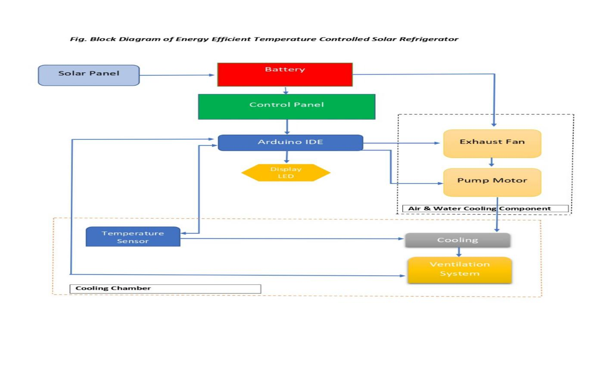

As Shown in above fig. Solar refrigerator works on the principle of evaporating and refrigerating technique mainly it consists of

1. Cooling Chamber

2. Control System

3. Ventilation system

4. Supply System

1. Cooling chamber: - An air packed perfect metal body with front portion of transparent sheet for visual. As metal body is used for it doesn’t pass atmospheric heat inside the body. A clay pot chamber is placed inside the metal body for storing Leafy vegetables and fruits. When the temperature of clay pot is rises the motor will get start spraying water and cooling fans will get start. This process repeat again and again till the temperature of the clay pot will not get below ambient temperature.

2. Control System: - An Arduino Uno based temperature detection system is designed which will measure the temperature inside the clay pot and Relay module is used to operate cooling fans and Pump motor.

3. Ventilation system: - The major role in temperature Controlling and maintaining will be done by ventilation system. It consists of exhaust fan in the right side of metal body and outlet duct at bottom of the refrigerator by which the remaining water will pass to the water tank. The DC fans are used for maintaining temperature. There are mainly two cases I. When the temperature is more than the required temperature at this condition the cooling fans and a exhaust fan will be started and it will further dissipate heat outside the chamber and hence decreases the temperature. II. When the temperature is less than the ambient temperature at this condition the total ventilation system will get shut down.

4. Supply System: - For economical and reliable operation of the equipment hybrid supply system is used. Solar panels and batteries are used for the controlling and switching of the ventilation system. The pump motor and cooling fans is supplied by either batteries or conventional AC supply for convenient use

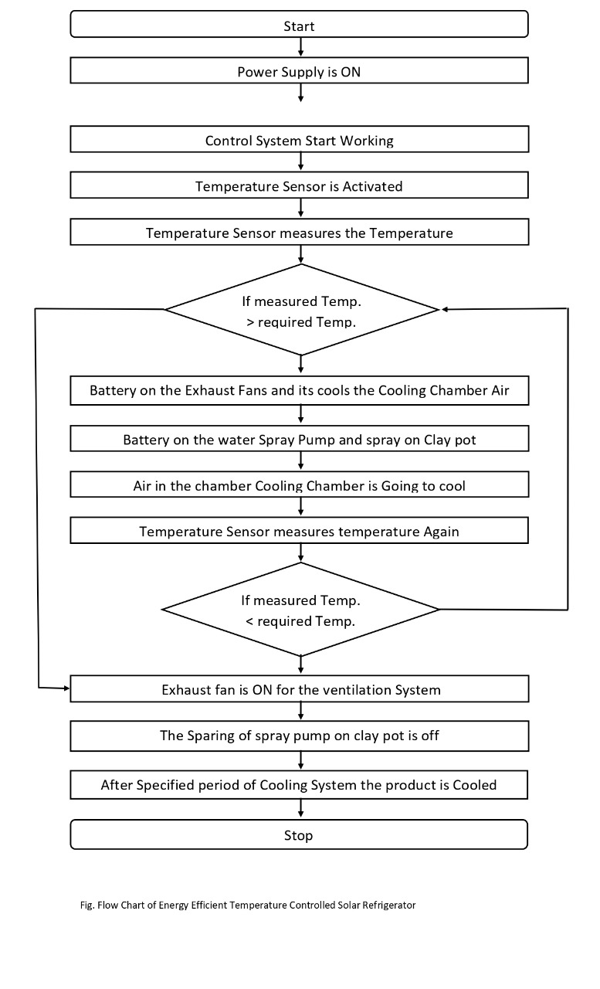

**Design of Model :**

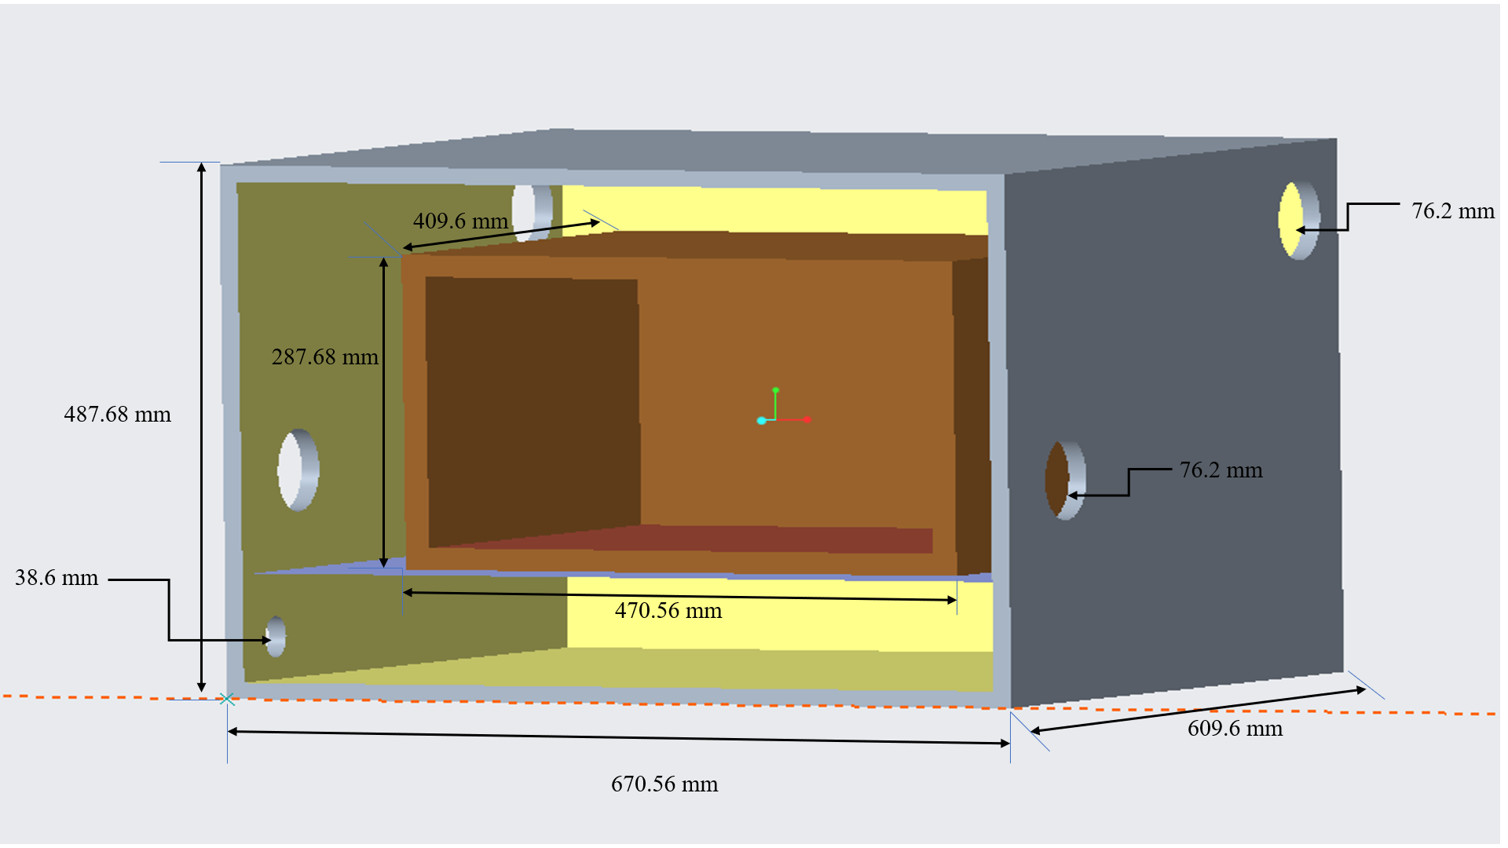

1. **Feasibility and Timeline:**

General methods use for cooling of vegetables fruits is done by natural water spraying on it. A very few techniques such as refrigerator are available in the market for the same purpose. But the main disadvantage in food storage and processing industries use natural cooling process which decreases amount of nutrition and its self-life. By use of evaporating technique, the nutrients present in the vegetables and fruits is more than the similar one which store in the normal refrigerator. So, this improves the quality of vegetables that store in the solar refrigerator. It will be commercially beneficial. As India has big export market for leafy vegetables and fruits. This Solar Based Evaporating Technology will be efficient as it cools in less time. The farmer and vendors will get maximum advantage out of this device as it will be one time investment for them and will benefit them throughout the life of the device which is around 6 to 7 years based on the life of clay pot. It will save the farmers from financial loss by providing them with proper preserving technique and saving the electricity bill because of the use of solar panels in the device.

**Hardware Requirements**

• Metal Sheet Box

• Clay Pot

• Exhaust Fan

• Relay Model

• Arduino UNO

• Display 16*2

• Temp. Sensors

• Pipe

• Spray Pump Motor

• Nozzles

• T & Elbows

• Glass

• 12v 8Ahr Battery

• Solar Panel (12v)

• 12v Adaptor

**Software Requirements**

1. Arduino IDE
2. Portus 8
3. **Conclusion:**

General method used for cooling of vegetables and fruits is done by natural cooling which is subjected to environmental conditions and a very few techniques are available in the markets for the same purpose. But the main dis-advantage in the food storage and processing industries use freezing cooling process which decrease the amount of nutrition from the food and it costly.

By use of energy efficient technique the nutrients present in the substance is more than the similar one cooled by freezer cooling, so it is improve the quality of substance and it will commercially beneficial. As India has big export market for leafy vegetables and products like Cabbage, Spinach, Mint, Curry leaves, Fenugreek, lettuce, Beet green, Turnip Greens, Mustard greens, Kale, Fennel greens.

**References:**

* MIT D LAB: <https://d-lab.edu/about>
* Institute d’ Economies Rurales (IER) Laboratories de Technologies Alimentaria
* World Vegetable Center–West and Central Africa Station de Recherche de Samanko, BP 320 Bamako, Mali
* Ambuko, J., Wanjiru, F., Chemining’wa, G. N., Owino, W. O., & Eliakim, M. (2017). Preservation of Postharvest Quality of Leafy Amaranth (Amaranthus spp.) Vegetables Using Evaporative Cooling. Journal of Food Quality. Basediya, A. l., Samuel, D. K., & Beera, V. (2011). Evaporative cooling system for storage of fruits and vegetables - a review (Vol. 50). Journal of Food Science and Technology. Emana, B., AfariSefa, V., Nenguwo, N., Ayana, A., Kebede, D., & Mohammed, H. (2017). Characterization of preand postharvest losses of tomato supply chain in Ethiopi
* Agriculture & Food Security. Gorny, J. R. (2001). A summary of CA and MA requirements and recommendations for fresh-cut (minimally processed) fruits and vegetables. Postharvest Horticulture Series, University of California, Davis. Kader, A. A. (2005). Increasing Food Availability by Reducing Postharvest Losses of Fresh Produce. Proceedings 5th International Postharvest Symposium.